Contact Management System

**CMPT 308N-113**

**11161**

**The Data Bros**

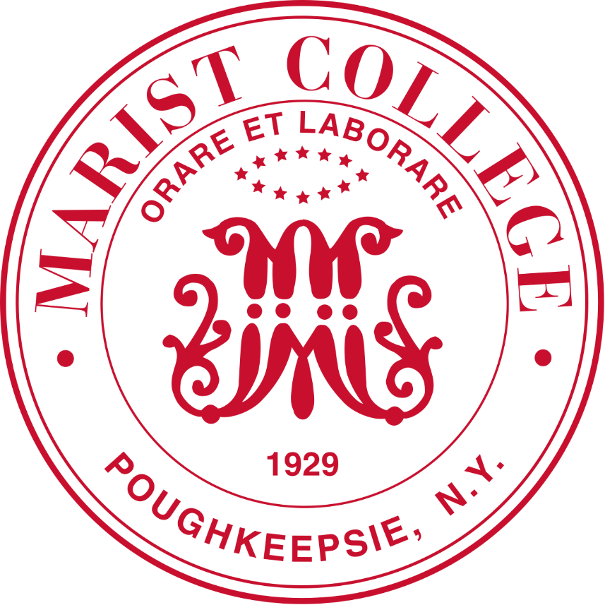

**Marist College School of Computer Science and Mathematics**

Shane Seeley (Team Leader)

Email: [shane.seeley1@marist.edu](mailto:shane.seeley1@marist.edu)

Jozef Maselek

Email: [jozef.maselek1@marist.edu](mailto:jozef.maselek1@marist.edu)

**Why we Make a Great Team**

Jozef’s Paragraph:

I want to work with Shane because I know he is a student who makes good decisions on essential requirements. I know that he can lead our team to meet project conditions and submit work on time. Shane is a good leader due to his tenacity in doing every task assigned to him. Shane is also a hard worker and I know that he will submit our projects on time and get his work done effectively.

Shane’s Paragraph:

I am excited to work with Jozef because I know we can get our work done on time and answer questions efficiently. We both are passionate about computer science and learning about topics like databases. The reason for me being the team leader is due to my knowledge of SQL and my personality, which will help guide our team to being as effective as possible.

Different Contact Management Systems:

**Cloud-Based Contact Management System “Google Contacts”:**

Advantages: Contacts are accessible from any device with internet access, and data is backed up regularly, which reduces the risk of data loss.

Disadvantages: Requires an internet connection to access data, which can create limitations.

**CRM Systems “Salesforce”:**

Advantages: Automation CRM systems automate specific tasks like email campaigns and customer interactions using stored data.

Disadvantages: CRM systems can be expensive and may not be needed for small businesses.

**Spreadsheet Software “Excel”:**

Advantages: allows for flexibility with data organization and sorting, data can also be integrated with other software using Excel.

Disadvantages: Version control issues collaboration in Excel can be challenging for data entry.

**Why our Software is the right choice and Our Goals.**

We believe that our system will be cost-effective and perfect for small businesses looking for a Contact Management System. We will create a secure SQL database to store customers’ information that users can easily access with a state-of-the-art user interface. Our system will have up-to-date security making it perfect for storing user data. With our Contact Management System users can get the best possible CMS for a price that’s affordable.